Composite Solids with Flat and Conical Surfaces

Definition
# Source: AI Source: Provided by: [Data Path: Persons Table -> ID Column: 1, Name_En Column: Motasem Essam] -> From: [ChatGPT] on [7/25/2026]
Composite Solids with Flat and Conical Surfaces are three-dimensional geometric solids formed by combining two or more solid components whose external boundaries include both flat surfaces and conical curved surfaces.
These composite solids contain planar faces, such as squares, rectangles, triangles, and circles, together with conical curved surfaces. They are commonly formed by combining cones or conical frustums with prisms, cubes, cylinders, pyramids, or other solid shapes.
The resulting solid may have flat bases, flat side faces, circular faces, and one or more curved conical surfaces.

Simple Definition
# Source: AI Source: Provided by: [Data Path: Persons Table -> ID Column: 1, Name_En Column: Motasem Essam] -> From: [ChatGPT] on [7/25/2026]
A composite solid with flat and conical surfaces is a 3D shape that combines flat faces with conical curved surfaces.

Geometric Representation
# Source: AI Source: Provided by: [Data Path: Persons Table -> ID Column: 1, Name_En Column: Motasem Essam] -> From: [ChatGPT] on [7/25/2026]
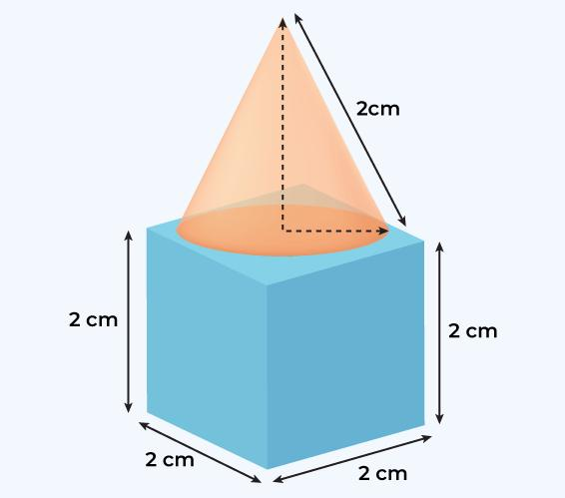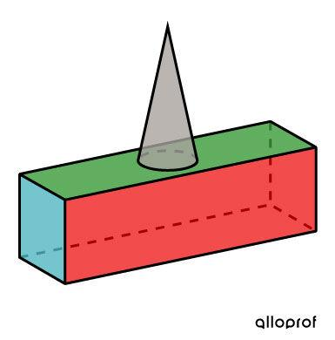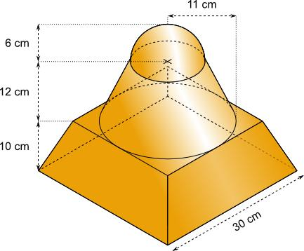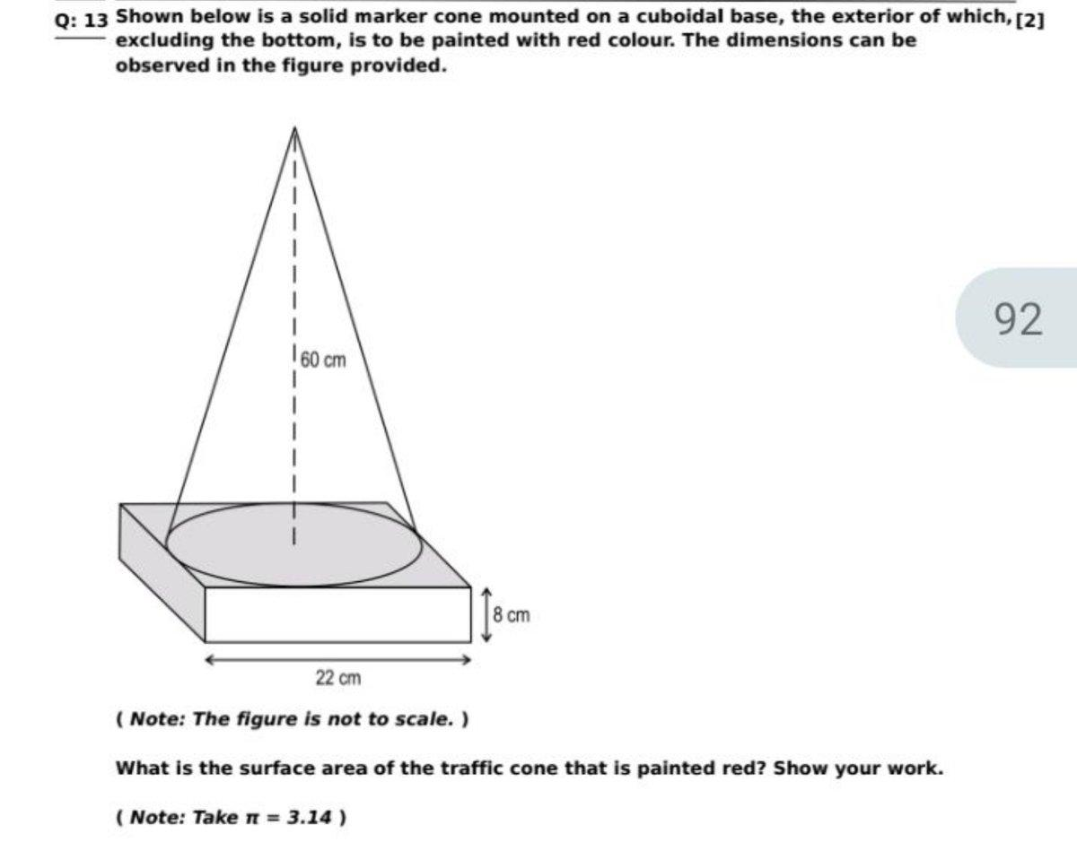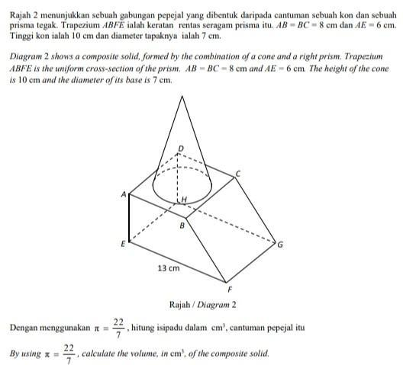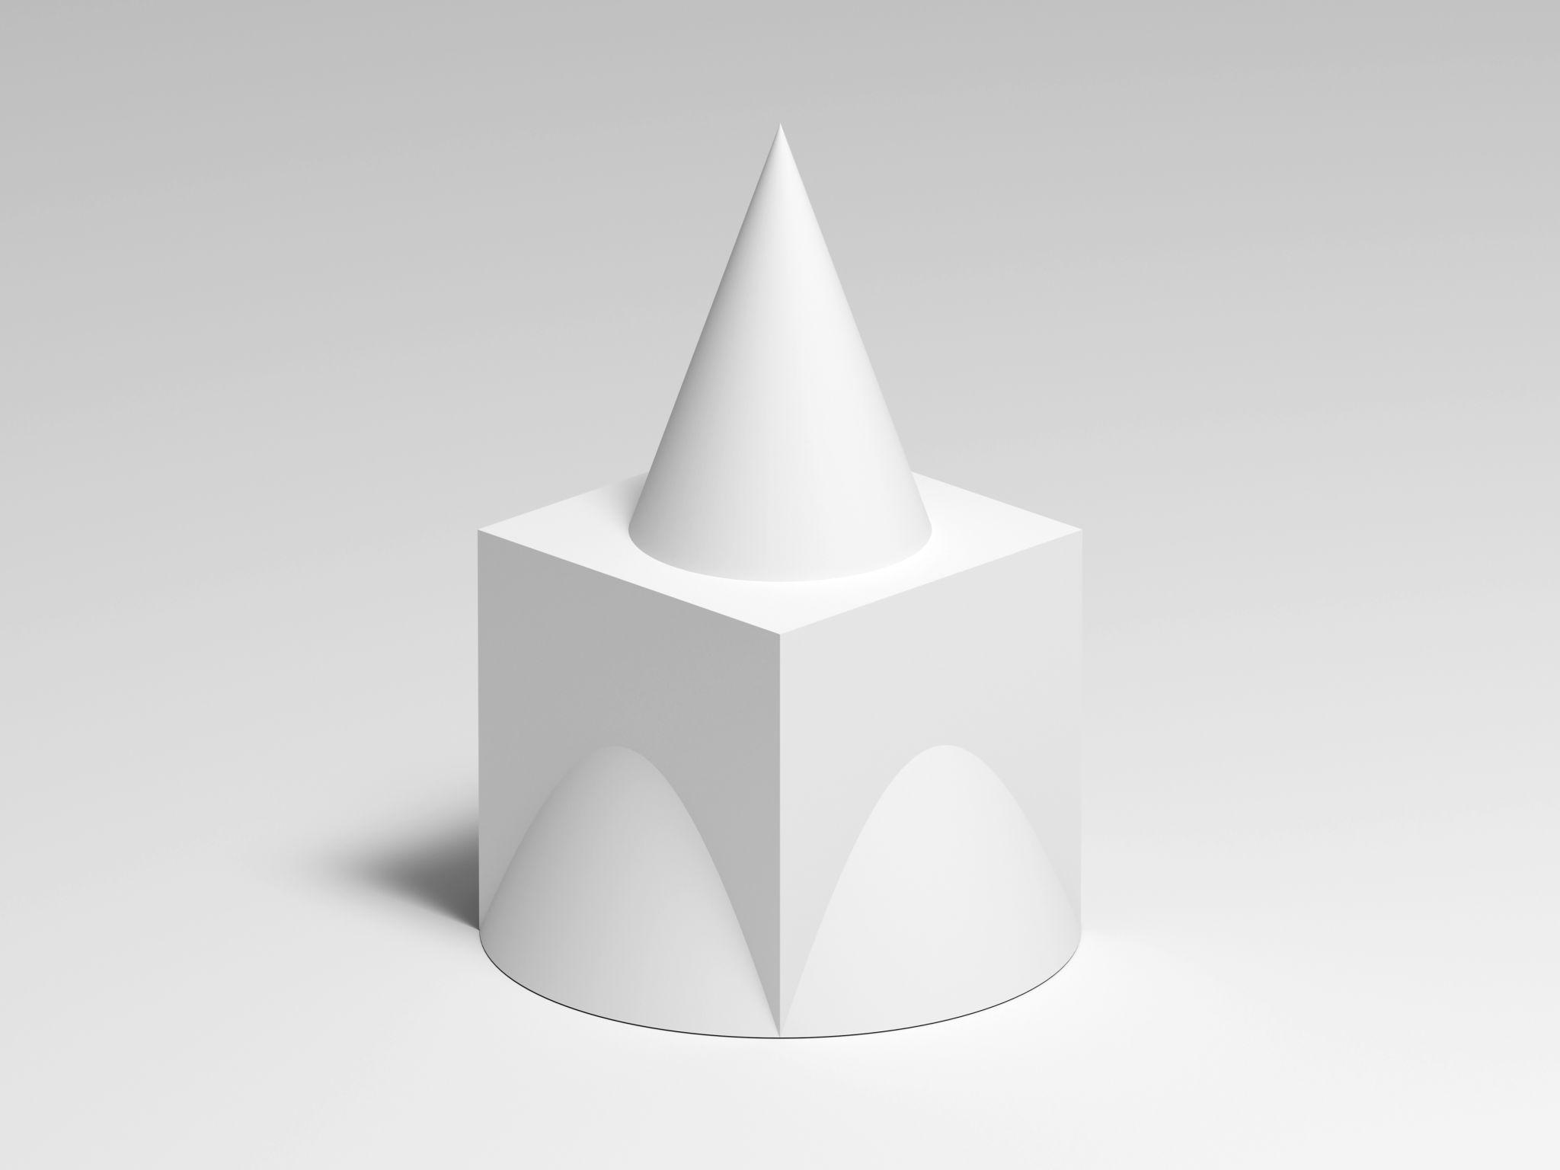
The main surface types are:
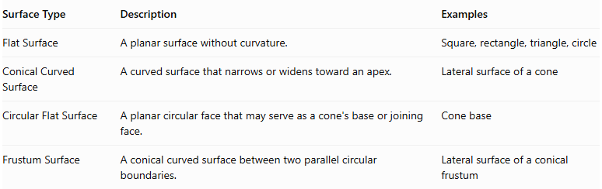
Surface Type | Description | Examples
Flat Surface | A planar surface without curvature. | Square, rectangle, triangle, circle
Conical Curved Surface | A curved surface that narrows or widens toward an apex. | Lateral surface of a cone
Circular Flat Surface | A planar circular face that may serve as a cone's base or joining face. | Cone base
Frustum Surface | A conical curved surface between two parallel circular boundaries. | Lateral surface of a conical frustum
Important: A cone has one flat circular base and one curved conical lateral surface. A conical frustum has two flat circular bases of different radii and one curved conical lateral surface.

Main Classification
# Source: AI Source: Provided by: [Data Path: Persons Table -> ID Column: 1, Name_En Column: Motasem Essam] -> From: [ChatGPT] on [7/25/2026]
Composite solids with flat and conical surfaces can be classified according to the types of flat-faced components combined with cones or conical frustums.

Prism-Based Composite Solids
# Source: AI Source: Provided by: [Data Path: Persons Table -> ID Column: 1, Name_En Column: Motasem Essam] -> From: [ChatGPT] on [7/25/2026]
A prism-based composite solid combines one or more prisms with cones or conical frustums.
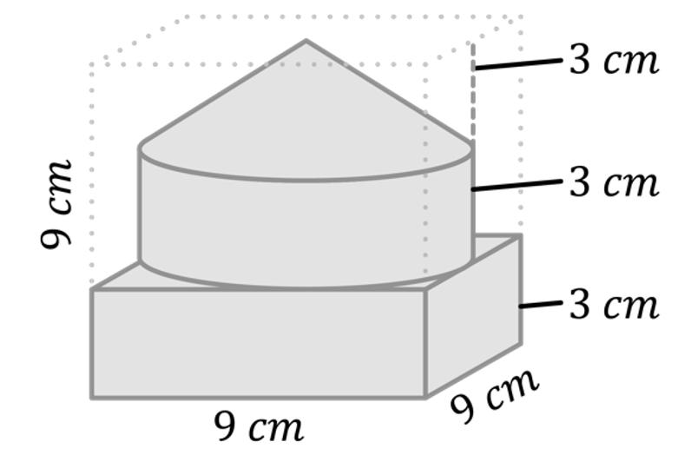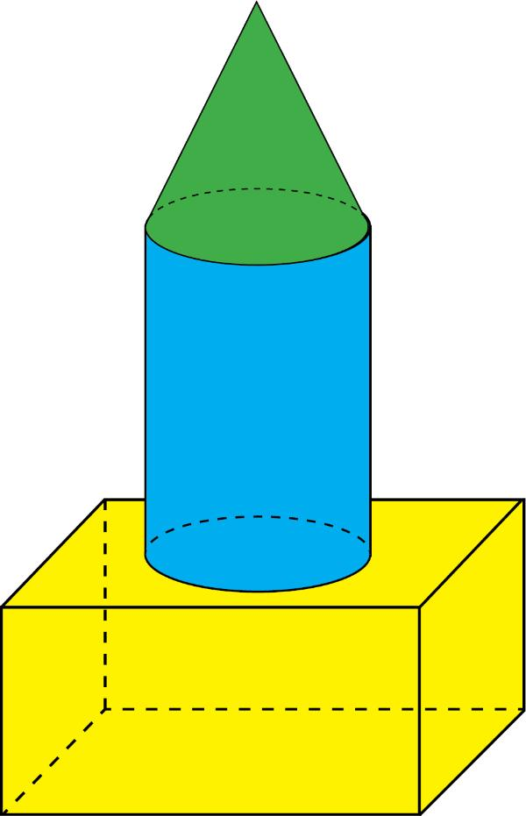
Examples:
- Rectangular Prism with a Cone
- Cube with a Cone
- Triangular Prism with a Cone
- Polygonal Prism with a Cone
- Rectangular Prism with a Conical Frustum
- Multiple Prisms with Conical Components

Cylinder-Based Composite Solids
# Source: AI Source: Provided by: [Data Path: Persons Table -> ID Column: 1, Name_En Column: Motasem Essam] -> From: [ChatGPT] on [7/25/2026]
A cylinder-based composite solid combines cylindrical components with cones or conical frustums.
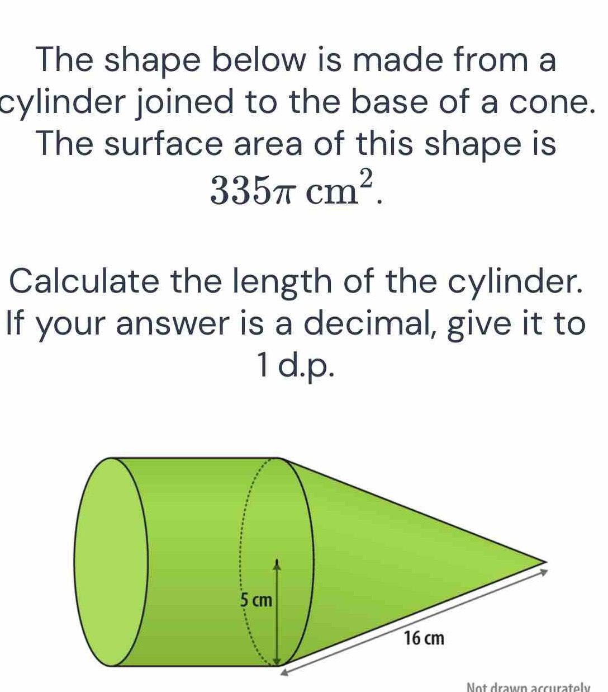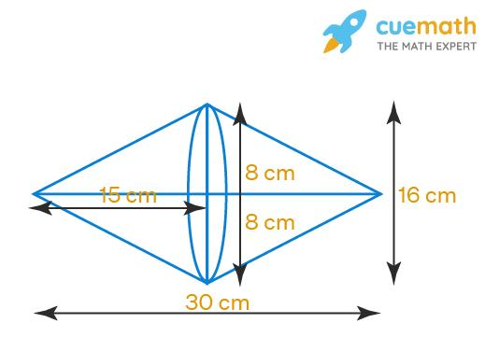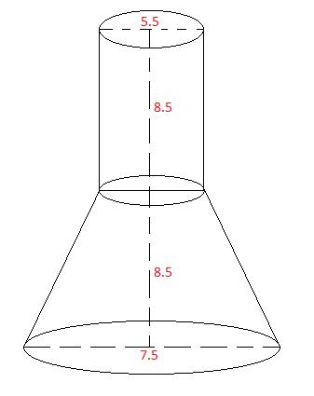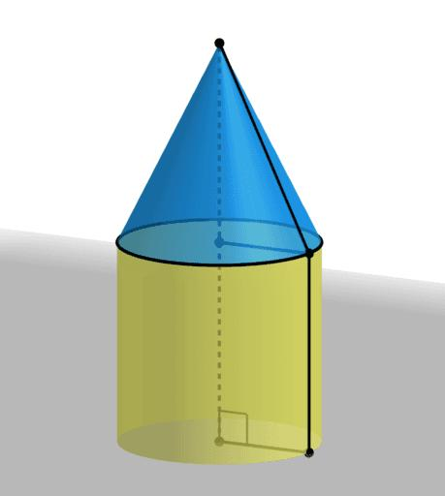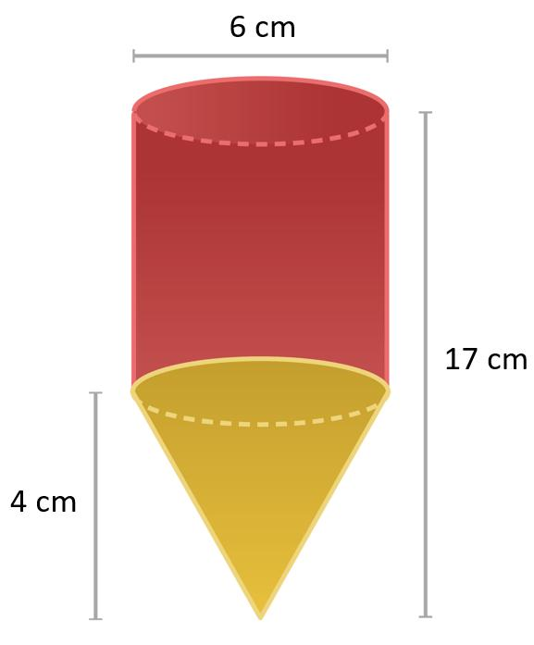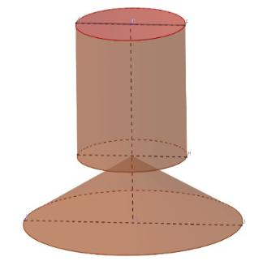
Examples:
- Cylinder with a Cone
- Cylinder with an Inverted Cone
- Cylinder with a Conical Frustum
- Coaxial Cylinder and Cone
- Multiple Cylinders with Conical Components

Pyramid-Based Composite Solids
# Source: AI Source: Provided by: [Data Path: Persons Table -> ID Column: 1, Name_En Column: Motasem Essam] -> From: [ChatGPT] on [7/25/2026]
A pyramid-based composite solid combines pyramids with cones or conical frustums.
Examples:
- Square Pyramid with a Cone
- Triangular Pyramid with a Cone
- Pentagonal Pyramid with a Cone
- Pyramid with a Conical Frustum
- Multiple Pyramids with Conical Components

Cone-Based Composite Solids
# Source: AI Source: Provided by: [Data Path: Persons Table -> ID Column: 1, Name_En Column: Motasem Essam] -> From: [ChatGPT] on [7/25/2026]
A cone-based composite solid combines two or more cones or conical frustums, potentially with different dimensions and orientations.
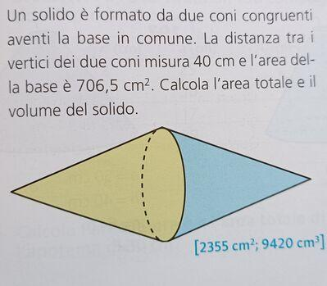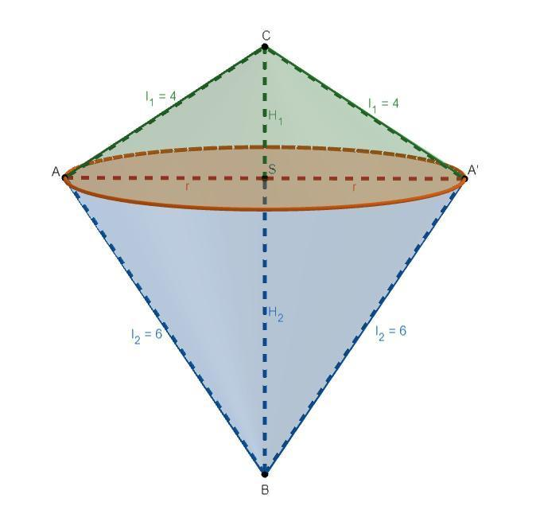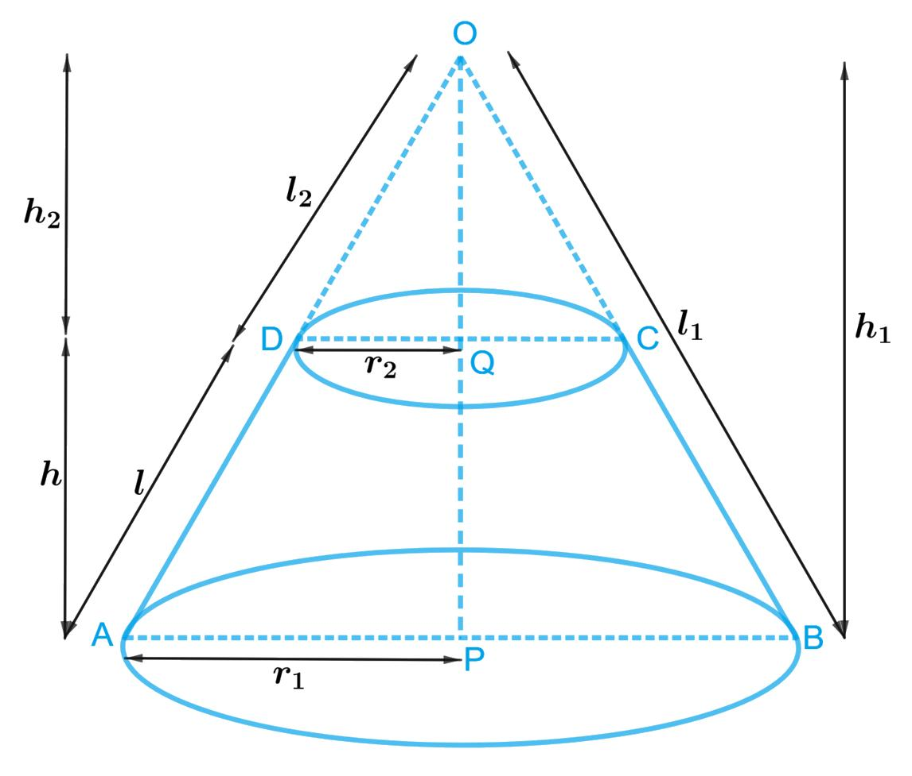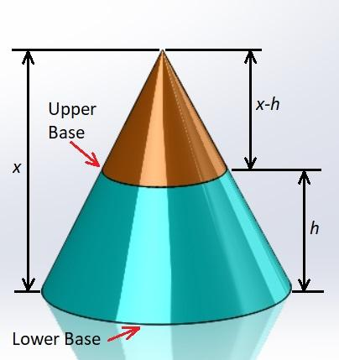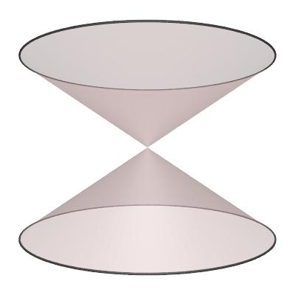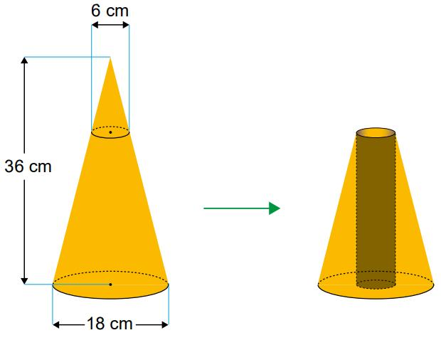
Examples:
- Two Cones Joined Base-to-Base
- Two Cones Joined Apex-to-Apex
- Coaxial Cones with Different Dimensions
- Cone with a Conical Frustum
- Multiple Cones with Different Orientations

Mixed-Shape Composite Solids
# Source: AI Source: Provided by: [Data Path: Persons Table -> ID Column: 1, Name_En Column: Motasem Essam] -> From: [ChatGPT] on [7/25/2026]
A mixed-shape composite solid combines conical components with different types of flat-faced solids.
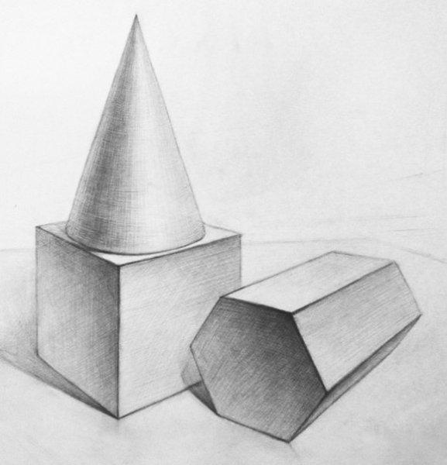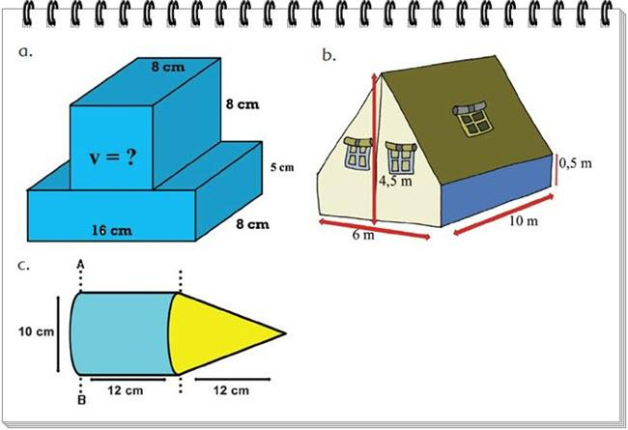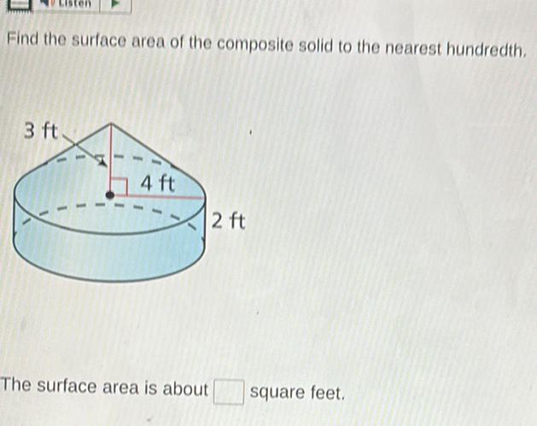
Examples:
- Cone with a Cube and a Cylinder
- Cone with a Rectangular Prism and a Pyramid
- Conical Frustum with Multiple Prisms
- Multiple Cones with Different Prisms
- Complex Mixed-Shape Composite Solids

Classification by Surface Arrangement
# Source: AI Source: Provided by: [Data Path: Persons Table -> ID Column: 1, Name_En Column: Motasem Essam] -> From: [ChatGPT] on [7/25/2026]
The external surfaces can also be classified according to how flat and conical surfaces are arranged.
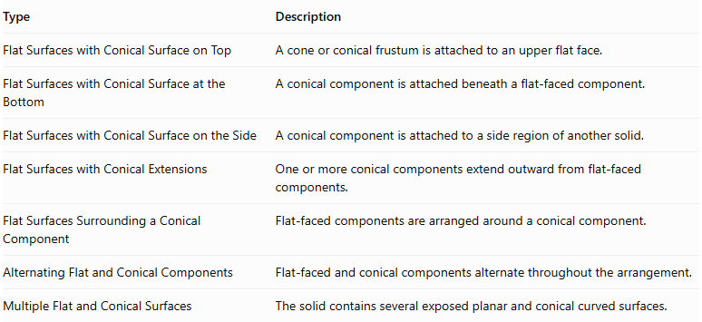
Type | Description
Flat Surfaces with Conical Surface on Top | A cone or conical frustum is attached to an upper flat face.
Flat Surfaces with Conical Surface at the Bottom | A conical component is attached beneath a flat-faced component.
Flat Surfaces with Conical Surface on the Side | A conical component is attached to a side region of another solid.
Flat Surfaces with Conical Extensions | One or more conical components extend outward from flat-faced components.
Flat Surfaces Surrounding a Conical Component | Flat-faced components are arranged around a conical component.
Alternating Flat and Conical Components | Flat-faced and conical components alternate throughout the arrangement.
Multiple Flat and Conical Surfaces | The solid contains several exposed planar and conical curved surfaces.

Classification by Component Arrangement
# Source: AI Source: Provided by: [Data Path: Persons Table -> ID Column: 1, Name_En Column: Motasem Essam] -> From: [ChatGPT] on [7/25/2026]
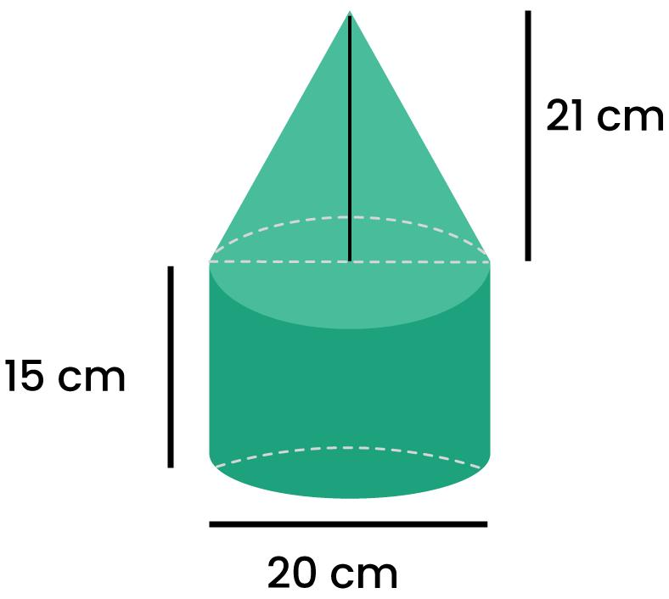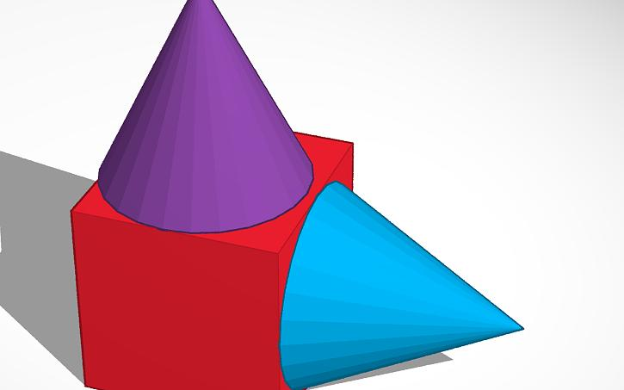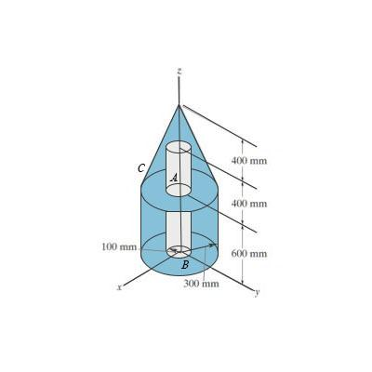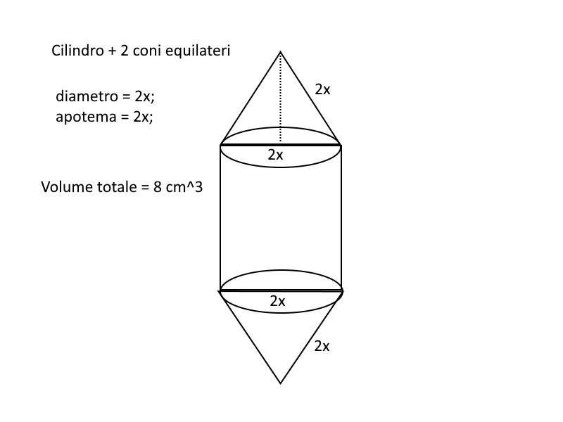
- Stacked Arrangement: Conical and flat-faced components are placed above or below one another.
- End-to-End Arrangement: Components are connected consecutively along a common direction.
- Side-Attached Arrangement: Conical components are attached to side faces or regions of flat-faced components.
- Coaxial Arrangement: Conical components share a common central axis, possibly with different radii or heights.
- Apex-to-Base Arrangement: The apex of one conical component connects to the base region of another component.
- Base-to-Base Arrangement: Two conical components are joined through their circular bases.
- Multi-Directional Arrangement: Components extend in different directions from a central component.

Mathematical Properties and Formulas
# Source: AI Source: Provided by: [Data Path: Persons Table -> ID Column: 1, Name_En Column: Motasem Essam] -> From: [ChatGPT] on [7/25/2026]
The volume and surface area depend on the dimensions, shapes, and joining arrangements of the component solids.

Volume
# Source: AI Source: Provided by: [Data Path: Persons Table -> ID Column: 1, Name_En Column: Motasem Essam] -> From: [ChatGPT] on [7/25/2026]
For components joined without overlapping interiors:
$$V_{total}=\sum_{i=1}^{n}{V_{i}}$$
For a composite solid containing a rectangular prism and a cone:
$$V_{total}=V_{prism}+V_{cone}$$
Rectangular prism:
$$V_{prism}=lwh$$
Cone:
<LearningViz typeid="CONEVOLUME" initial_values={{"radius":3,"height":8}} />
Where:
- $r$ = radius of the cone's circular base.
- $h_{c}$ = perpendicular height of the cone.
Therefore:
$$\boxed{V_{total}=lwh+\frac{1}{3}πr^{2}h_{c}}$$
For a conical frustum:
$$V_{f}=\frac{1}{3}πh_{f}(R^{2}+Rr+r^{2})$$
Where:
- $R$ = larger base radius.
- $r$ = smaller base radius.
- $h_{f}$ = perpendicular height of the frustum.

Surface Area
# Source: AI Source: Provided by: [Data Path: Persons Table -> ID Column: 1, Name_En Column: Motasem Essam] -> From: [ChatGPT] on [7/25/2026]
The external surface area is calculated by adding the exposed surfaces of all components and excluding hidden joining regions.
For a rectangular prism:
$${SA}_{p}=2(lw+lh+wh)$$
For a right circular cone:
$${SA}_{c}=πr^{2}+πrs$$
Where $s$ is the slant height:
$$s=\sqrt{r^{2}+h_{c}^{2}}$$
For a conical frustum:
$${SA}_{f}=π(R+r)s+πR^{2}+πr^{2}$$
Where its slant height is:
$$s=\sqrt{h_{f}^{2}+(R-r)^{2}}$$
If a cone is attached to a rectangular prism through a circular base completely contained within one flat face:
$${SA}_{total}={SA}_{p}+{SA}_{c}-2πr^{2}$$
Simplifying:
$$\boxed{{SA}_{total}={SA}_{p}+πrs}$$
This assumes the entire circular base of the cone is hidden at the joining region, with no other overlapping surfaces.

Worked Examples

Example 1: Rectangular Prism with a Cone on Top
# Source: AI Source: Provided by: [Data Path: Persons Table -> ID Column: 1, Name_En Column: Motasem Essam] -> From: [ChatGPT] on [7/25/2026]
Given:
- Rectangular prism: $10×8×6$ cm.
- Cone radius: $2$ cm.
- Cone height: $3$ cm.
- The cone is attached to the top face, with its circular base completely inside that face.
Step 1: Calculate the rectangular prism volume.
$$V_{p}=10×8×6=480$$
Step 2: Calculate the cone volume.
$$V_{c}=\frac{1}{3}π(2)^{2}(3)$$
$$V_{c}=4π$$
Step 3: Calculate total volume.
$$V=480+4π$$
$$\boxed{V≈492.57{ cm}^{3}}$$
Step 4: Calculate the rectangular prism surface area.
$${SA}_{p}=2(10×8+10×6+8×6)$$
$${SA}_{p}=376{ cm}^{2}$$
Step 5: Calculate the cone slant height.
$$s=\sqrt{2^{2}+3^{2}}$$
$$s=\sqrt{13}$$
Step 6: Calculate the exposed cone curved surface area.
$${CSA}_{c}=πrs$$
$${CSA}_{c}=2π\sqrt{13}$$
Step 7: Calculate the external surface area.
The circular joining region is hidden on both components:
$$SA=376+2π\sqrt{13}$$
$$\boxed{SA≈398.65{ cm}^{2}}$$

Example 2: Cylinder with a Conical Frustum on Top
# Source: AI Source: Provided by: [Data Path: Persons Table -> ID Column: 1, Name_En Column: Motasem Essam] -> From: [ChatGPT] on [7/25/2026]
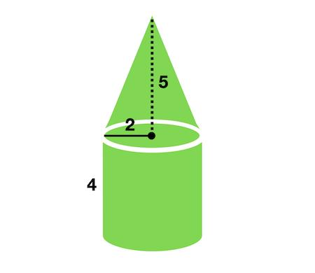
Given:
- Cylinder radius: $3$ cm.
- Cylinder height: $8$ cm.
- Conical frustum larger radius: $3$ cm.
- Conical frustum smaller radius: $1$ cm.
- Frustum height: $3$ cm.
- The frustum's larger circular base is attached completely to the cylinder's top base.
Step 1: Calculate the cylinder volume.
$$V_{c}=π(3)^{2}(8)$$
$$V_{c}=72π$$
Step 2: Calculate the conical frustum volume.
$$V_{f}=\frac{1}{3}π(3)(3^{2}+3(1)+1^{2})$$
$$V_{f}=13π$$
Step 3: Calculate total volume.
$$V=72π+13π$$
$$\boxed{V=85π≈267.04{ cm}^{3}}$$
Step 4: Calculate the frustum slant height.
$$s=\sqrt{3^{2}+(3-1)^{2}}$$
$$s=\sqrt{13}$$
Step 5: Calculate the cylinder's exposed surface area.
The bottom circular base and curved lateral surface remain exposed:
$${SA}_{c}=2πrh+πr^{2}$$
$${SA}_{c}=2π(3)(8)+π(3)^{2}$$
$${SA}_{c}=57π$$
Step 6: Calculate the frustum's exposed surface area.
The larger circular base is hidden, while the smaller circular base and curved lateral surface remain exposed:
$${SA}_{f}=π(R+r)s+πr^{2}$$
$${SA}_{f}=4π\sqrt{13}+π$$
Step 7: Calculate total external surface area.
$$SA=57π+4π\sqrt{13}+π$$
$$SA=58π+4π\sqrt{13}$$
$$\boxed{SA≈226.94{ cm}^{2}}$$

Important Characteristics
# Source: AI Source: Provided by: [Data Path: Persons Table -> ID Column: 1, Name_En Column: Motasem Essam] -> From: [ChatGPT] on [7/25/2026]
- Mixed Surface Geometry: The solid contains planar surfaces and conical curved surfaces.
- Multiple Components: It is constructed from two or more geometric solids.
- Conical Components: These may include cones and conical frustums.
- Flat Joining Regions: Components can connect through complete or partial planar regions.
- Variable Orientation: Conical components may be positioned vertically, horizontally, or at inclined angles.
- Variable Dimensions: Components may have different base radii, heights, slant heights, and polygonal dimensions.
- Volume Calculation: Component volumes are added when their interiors do not overlap.
- Surface Area Calculation: Only exposed surfaces contribute to the external surface area.

Comparison with Other Surface Combinations
# Source: AI Source: Provided by: [Data Path: Persons Table -> ID Column: 1, Name_En Column: Motasem Essam] -> From: [ChatGPT] on [7/25/2026]
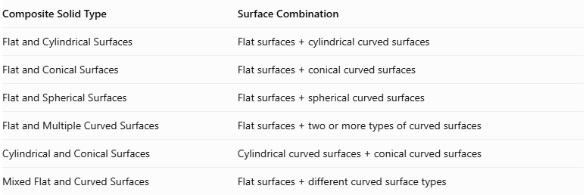
Composite Solid Type | Surface Combination
Flat and Cylindrical Surfaces | $$Flatsurfaces+cylindricalcurvedsurfaces$$
Flat and Conical Surfaces | $$Flatsurfaces+conicalcurvedsurfaces$$
Flat and Spherical Surfaces | $$Flatsurfaces+sphericalcurvedsurfaces$$
Flat and Multiple Curved Surfaces | $$Flatsurfaces+twoormoretypesofcurvedsurfaces$$
Cylindrical and Conical Surfaces | $$Cylindricalcurvedsurfaces+conicalcurvedsurfaces$$
Mixed Flat and Curved Surfaces | $$Flatsurfaces+differentcurvedsurfacetypes$$

Applications
# Source: AI Source: Provided by: [Data Path: Persons Table -> ID Column: 1, Name_En Column: Motasem Essam] -> From: [ChatGPT] on [7/25/2026]
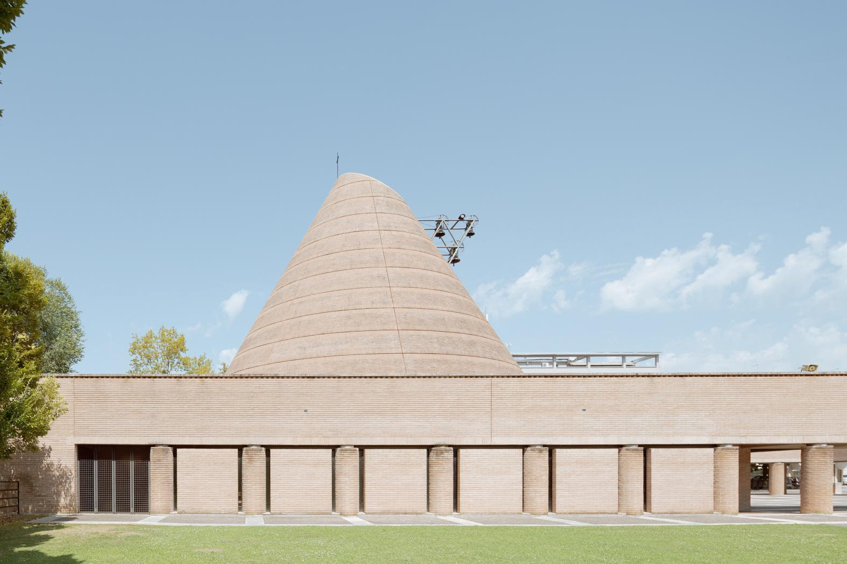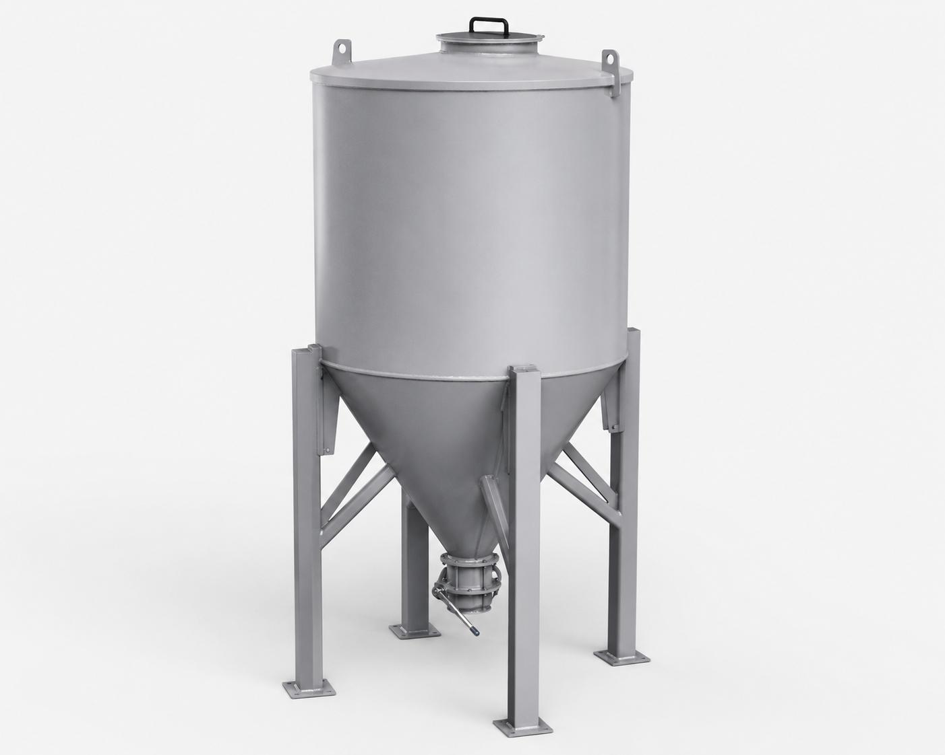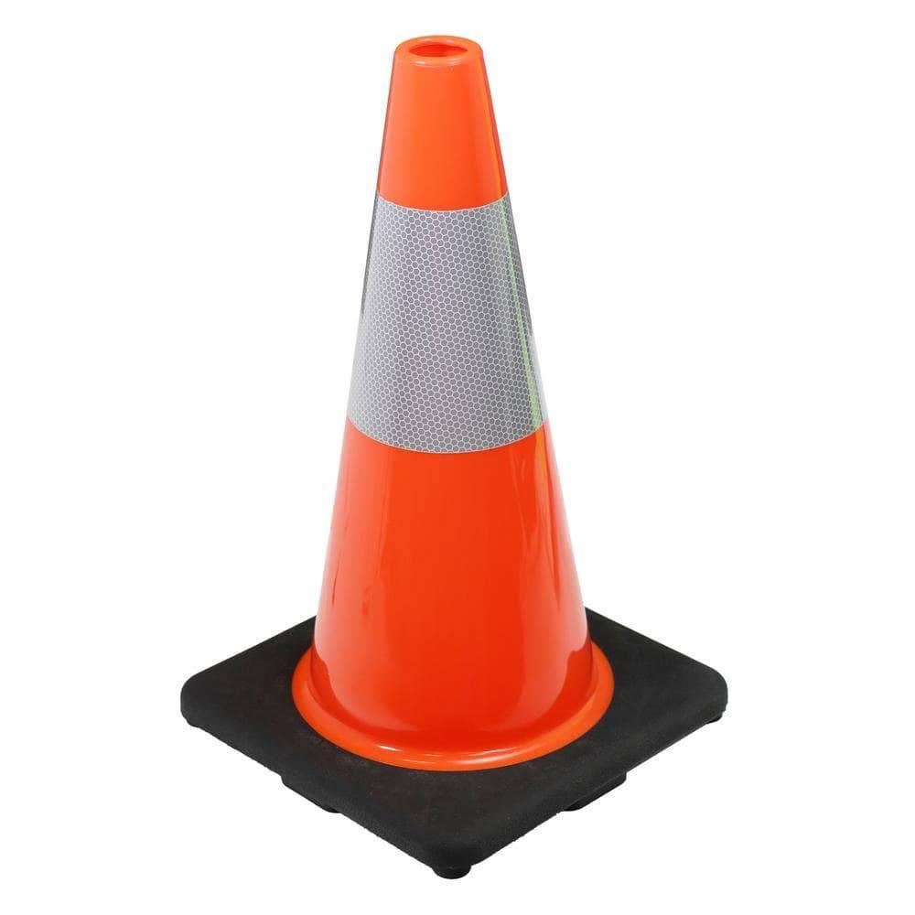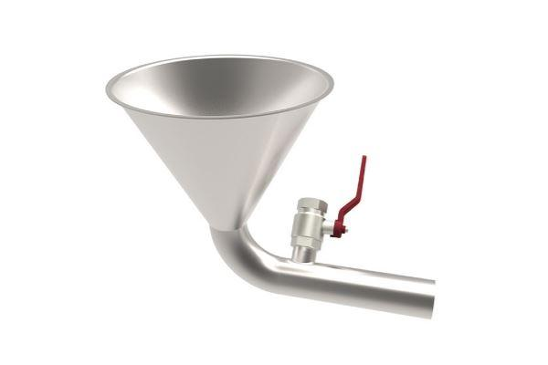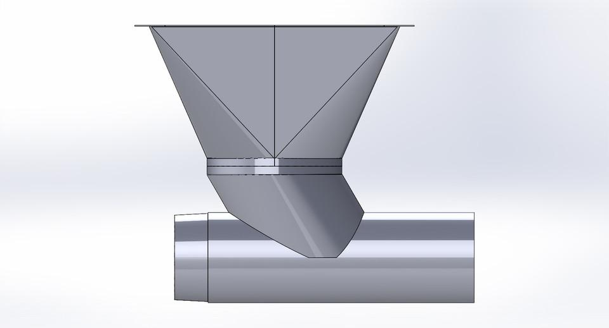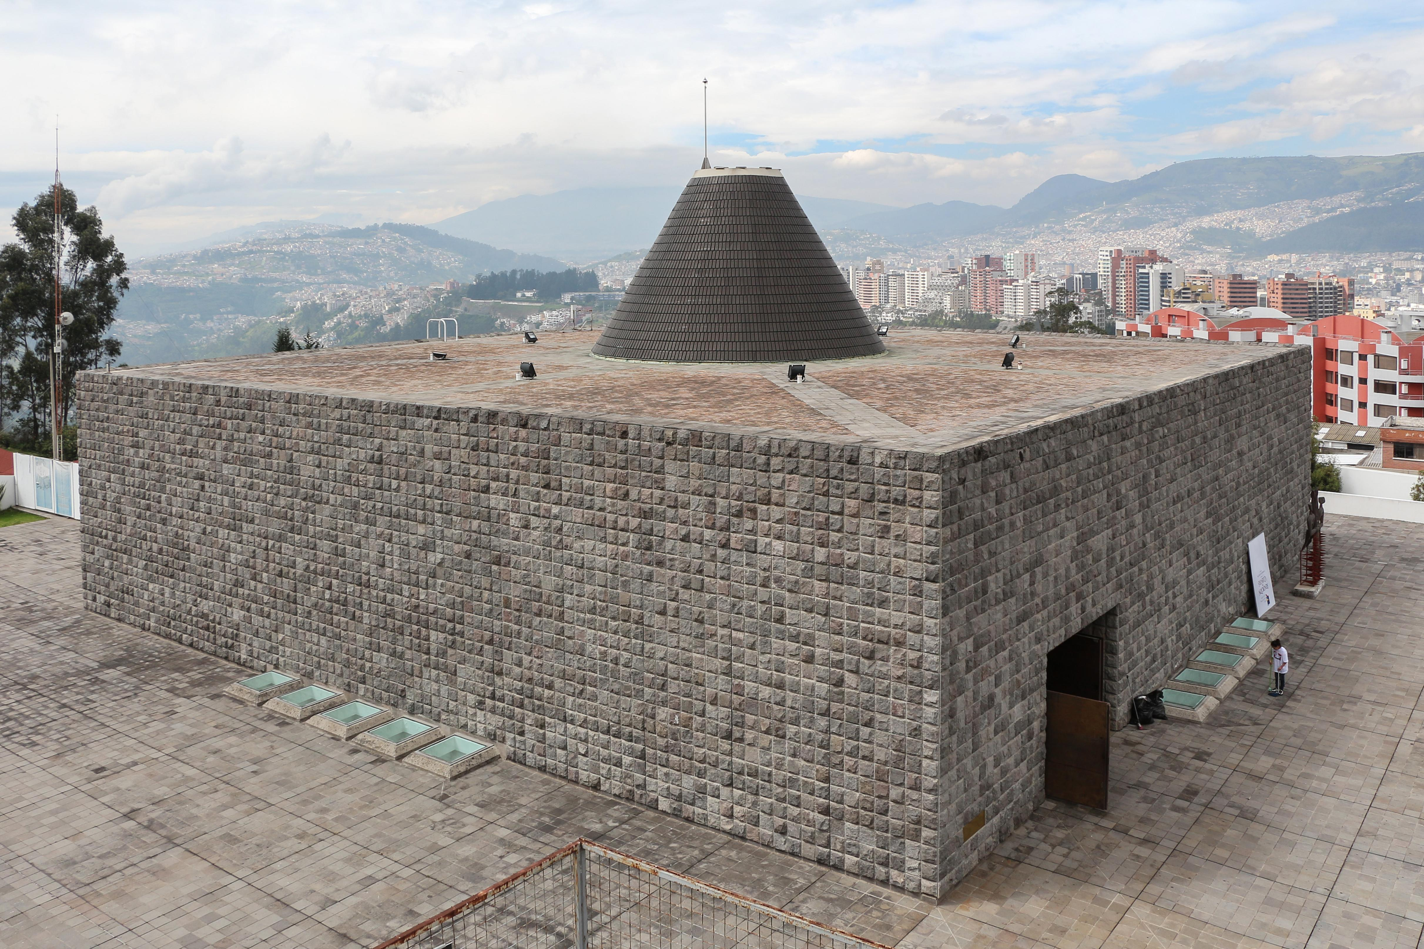
- Architecture: Buildings with conical roofs supported by rectangular or cylindrical structures.
- Industrial Storage: Tanks and containers with conical bottoms for material discharge.
- Mechanical Engineering: Funnels, hoppers, and conical components attached to machine housings.
- Construction: Structural supports and decorative structures combining flat-faced and conical forms.
- Product Design: Objects combining flat bases with cone-shaped extensions.

Key Points
# Source: AI Source: Provided by: [Data Path: Persons Table -> ID Column: 1, Name_En Column: Motasem Essam] -> From: [ChatGPT] on [7/25/2026]
- These composite solids combine flat surfaces with conical curved surfaces.
- They can include prisms, cubes, cylinders, pyramids, cones, and conical frustums.
- Their arrangements include stacked, side-attached, coaxial, base-to-base, and multi-directional configurations.
- Cone volume depends on its base radius and perpendicular height.
- Cone surface area depends on its base radius and slant height.
- Hidden joining regions must be excluded when calculating external surface area.

Conclusion
# Source: AI Source: Provided by: [Data Path: Persons Table -> ID Column: 1, Name_En Column: Motasem Essam] -> From: [ChatGPT] on [7/25/2026]
Composite Solids with Flat and Conical Surfaces are three-dimensional structures that combine planar faces with conical curved surfaces. They can be constructed from different combinations of prisms, cylinders, pyramids, cones, and conical frustums.
Their geometric analysis requires calculating the volume of each component and identifying the exposed surfaces while excluding hidden joining regions.

